The GBA Bulletin

From the Program director
The Geological and Bioregional Assessments (GBA) team is happy to present the new GBA newsletter.
This newsletter aims to bridge the gap between the program’s reports and user panel meetings. It gives the program an opportunity to share information on the methods the GBA team uses, and give you a greater insight into the assessments for regions other than your own.
The newsletter will be issued three times a year and will include a brief update on each of the GBA regions. It will focus on specific parts of each basin’s assessment, detail upcoming events and provide articles that explain key aspects of the program’s science.
The Cooper Baseline Synthesis report is nearing completion and is expected to be released in late 2019. It collates and assesses the available information for the region to form a foundational knowledge base and identify knowledge gaps for additional data collection.
The baseline synthesis includes geological and hydrological assessment of the basin, environmental data synthesis, hazard analysis and examination of areas and items of cultural heritage and environmental significance.
The baseline synthesis for the Isa and Beetaloo regions will follow the Cooper report, which will collate similar existing information and identify knowledge gaps.
The program has developed an overall ‘map’ of the program’s assessment process (included below) to highlight the key areas we intend to focus on throughout the three stages of the assessment.
We encourage you to share this newsletter more broadly within your communities and organisations, and in the future we will present further detail on the program’s reports and address some frequently asked questions.

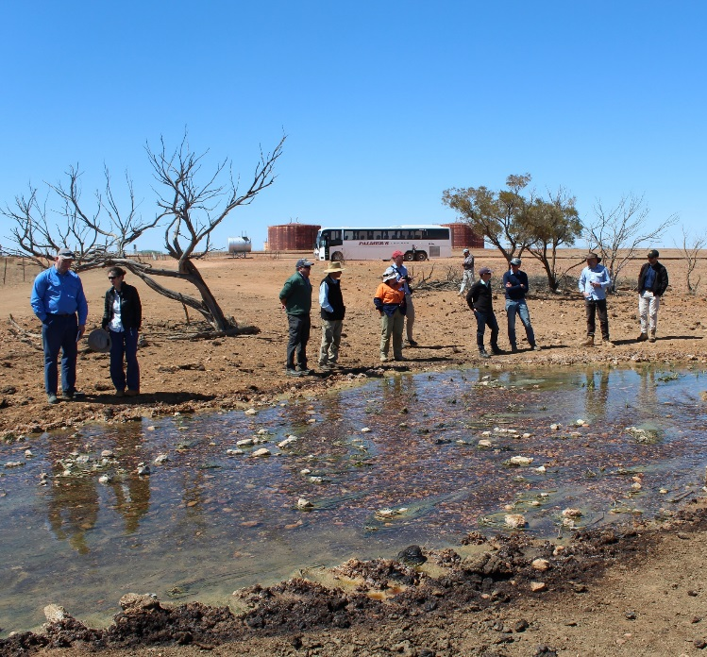
Stakeholders inspecting produced water at Jackson, Queensland. Source: GBA Program – Anthony Swirepik

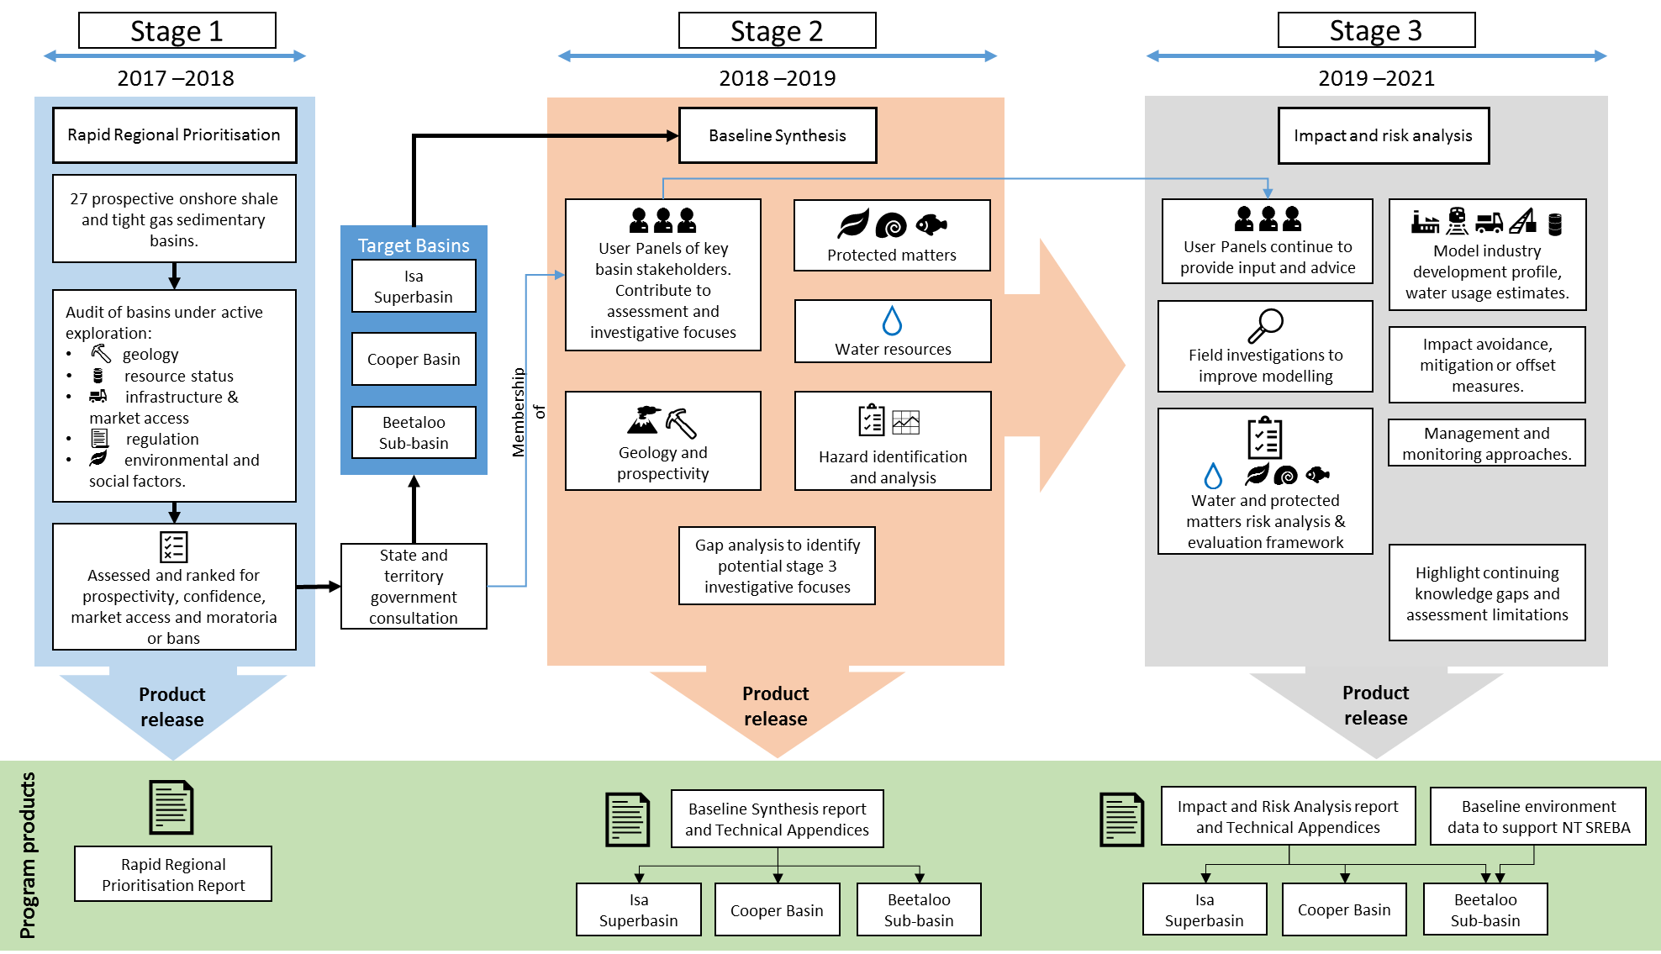

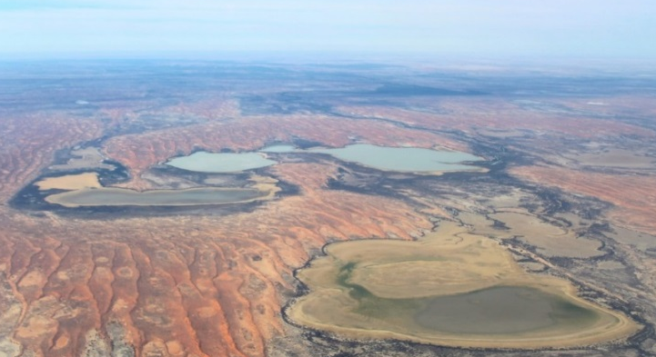
Cooper GBA region
The Cooper Creek system is subject to a range of flooding events, which support life in the system. We are building a flood model to help analyse the potential impact that future development could have on the system. To do this we are building a high-resolution digital elevation model with aerial Light Detection And Ranging (LiDAR) data collection for Stage 3 hydrological modelling. LiDAR captures high resolution data (approximately 1m scale) on river and water course features: channels, rock bars, gorges, floodplains, banks and infrastructure.
Coongie Lakes. Source: GBA Program – Alex Tomlinson
Water systems in the Cooper basin can be subject to large flood events, like those seen in April 2019. The hydrological model can be used to estimate inundation changes in current and future flooding events, determining connections between river channels and isolated wetland systems (such as Coongie Lakes, see image above) and assessing changes in water connections and flow rates. This includes assessments of changes to the system under future industry development scenarios. LiDAR data collection is about 57 per cent complete (see figure below), with the remainder on hold until the water recedes following recent flooding.

In Focus: LiDAR
Light Detection And Ranging (LiDAR), measures the distance from a source to a target by bouncing a laser light off its surface. Measurements of the returning wavelength and time taken to travel the distance allows high resolution information to be recorded and used to build 3-dimensional models. LiDAR is used in a range of applications from map making, to autonomous vehicles.
LiDAR rose to prominence as a remote sensing tool as part of the Apollo 15 mission in 1971, where it was used to map the surface of the moon. Airborne LiDAR, the system currently in use as part of the Cooper Basin Stage 3 Impact and Risk Analysis, enables detailed mapping of the terrain. LiDAR data collected through airborne systems is particularly useful in producing high resolution elevation maps, identifying river system extents, tracks or paths and cultural heritage sites.
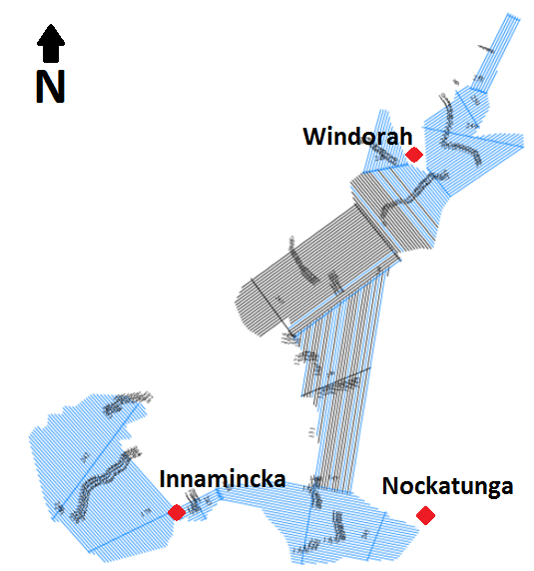
LiDAR data collection over the Cooper Creek floodplain. Blue lines have been ‘flown’, black are yet to be collected.

Beetaloo GBA region
The drafting of the Beetaloo Baseline Synthesis report and associated technical appendices is well advanced. These documents will be shortly entering the program’s comprehensive review process and are expected to be released in late 2019.
Technical Working Groups have been established to enhance collaboration between Geological and Bioregional Assessments (GBA) and the Northern Territory Government to support the delivery of the Strategic Regional Environmental and Baseline Assessment (SREBA) for the Beetaloo sub-basin. The first meeting occurred in Darwin on 22 May 2019. The Technical Working Groups will ensure alignment between the GBA program and SREBA and involves separate working groups for water, ecology and risk assessment.
The Second User Panel meeting occurred in Darwin on 23 May 2019. The meeting included presentations from CSIRO, Geoscience Australia, the Northern Territory Government and the gas industry. The communique from this meeting is now available at: https://www.bioregionalassessments.gov.au/assessments/geological-and-bioregional-assessment-program/beetaloo-sub-basin/beetaloo-sub-basin-user-panel-communiques.

In focus: Mataranka Springs
Located in Elsey National Park, 106km south of Katherine and 50km north of the Beetaloo GBA region, Mataranka Springs is a major contributor to base flow into the Roper River and streams throughout the Elsey National Park. The springs also support wetland systems that are listed under Directory of Important Wetlands in Australia (DIWA). The Mataranka Thermal Pool (see image) is a major tourist attraction for the region, maintaining a constant 34ºC all year round with approximately 30.4 Mega Litres of water passing through the pool from the Rainbow Spring daily.
The Mataranka Springs are fed by the Cambrian Limestone Aquifer (CLA), a significant water resource for agriculture and communities. The CLA incorporates two groundwater systems that flow into the Daly Basin and downstream to discharge in the northern parts of Mataranka Springs. The GBA assessment for the Beetaloo region will examine any additional contributing source aquifers of the Mataranka Springs and any connections between the CLA and deeper aquifers. By collecting baseline information the program will be able to examine any potential impacts to the springs from future gas industry development in the Beetaloo Sub-basin.
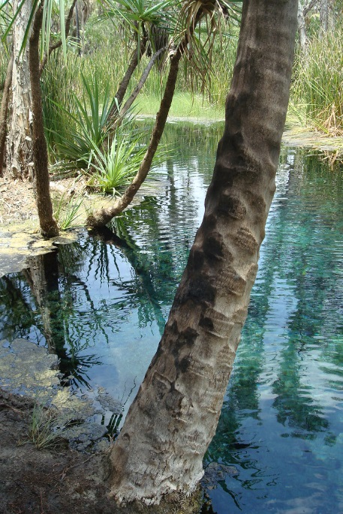

Mataranka Springs. Source: jimmy1979 (CC by-nc-nd 2.0)

Isa GBA region
Flooding associated with Tropical Cyclone Trevor (see image below of Flinders River in flood) resulted in the postponement of the second User Panel meeting planned for April. We are now working towards holding the User Panel meeting on 13 August 2019 in Normanton.
A first draft of the Isa Superbasin Stage 2 Baseline Synthesis report is close to completion and we will be giving you a first look at some of our results from the reports at our 6 August meeting. Keep an eye out for an email from us with a link to the report in late 2019.
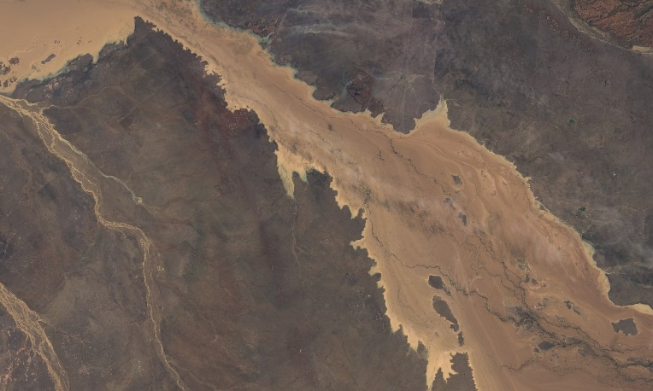
The 2019 flood in the Flinders River. Source: The Guardian - Sentintel Hub/Copernicus Sentinel satellite

In focus: Location and relationship with the Great Artesian Basin
The area of the Isa Superbasin being assessed by the program is located in far northwest Queensland—stretching from the Northern Territory border to Burketown, close to the shores of the Gulf of Carpentaria.
But did you know, most of this area lies within the Great Artesian Basin (GAB)? The GAB is the largest source of groundwater in Australia—covering a whopping 1.7 million square kilometres and containing an estimated 64,900 million mega litres, it is an important source of groundwater for towns, agriculture, industry, plants and animals across Queensland, New South Wales, South Australia and the Northern Territory. Many important groundwater-dependent ecosystems are also reliant on GAB springs.
Over the next two years, the GBA Program will assess potential impacts on GAB aquifers due to water extraction from a potential unconventional gas industry. This assessment will be supported by new research being undertaken to improve our understanding of GAB water sources.

Upcoming events
Event | Location | Date
Isa Superbasin User Panel meeting | Normanton, QLD | 13 August 2019
Beetaloo User Panel and Field Trip | TBA, NT | October/November 2019

