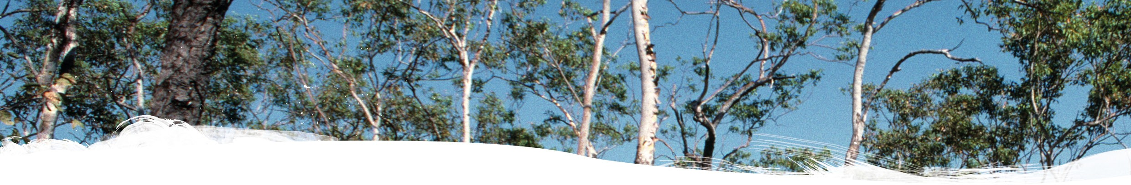

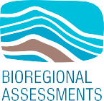
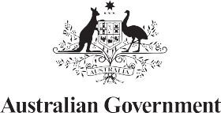
Impact assessment for the Beetaloo GBA region

Geological and Bioregional Assessment Program
The $35.4 million Geological and Bioregional Assessment (GBA) Program is assessing the potential impacts of shale and tight gas development on water and the environment. The geological and environmental knowledge, data and tools produced by the program will assist governments, industry, land users and the community by informing decision-making and enabling the coordinated management of potential impacts.
A series of independent scientific studies were conducted in 3 geological basins: the Cooper Basin in Queensland and South Australia, the Isa Superbasin in Queensland and the Beetaloo Sub-basin in the Northern Territory (referred to throughout as GBA regions). These studies have been conducted by CSIRO and Geoscience
Australia, supported by the Bureau of Meteorology and managed by the Department of Agriculture, Water and the Environment.
Assessments identified potential impacts on water and the environment. Causal networks were used to determine where potential impacts cannot be ruled out. Governments, industry and the community can then focus on areas that are potentially impacted and apply local-scale modelling when making regulatory, water management and planning decisions.

User panels
The GBA program has been informed by a series of user panels that provide a forum for the discussion and inclusion of user needs in each region. The user panel for the Beetaloo GBA region consists of representatives from relevant local governments, natural resource management bodies, Northern Territory Government, Traditional Owner groups, industry and other land user groups. The GBA Program team is grateful for the contributions of the user panel members over the course of this program.

Beetaloo GBA region
The Beetaloo GBA region (Figure 1) coincides with the extent of the Beetaloo Sub-basin and covers an area of about 28,000 km². The Beetaloo GBA region is located about 500 km south of Darwin and includes a substantial proportion of the Cambrian Limestone Aquifer, the principal water resource in the region. The region is sparsely populated, with Mataranka, Jilkminggan, Daly Waters and Elliott the most populated settlements in the surrounding area. The Beetaloo GBA region is prospective for significant unconventional gas resources that
include shale and tight gas, with potential for liquid hydrocarbons. The gas industry is in the exploration phase of the development life cycle, and there are no existing petroleum developments.

Key findings
The GBA Program developed a robust methodology using causal networks to assess the regional-scale risks of unconventional gas resource development on water and the environment. The methodology allows consistent analysis of risks at each step in a chain of events – called pathways – from gas resource development activities to protected environmental and water-related values. The methodology can be applied to other regional-scale assessments in the future.
The GBA Program has developed a publicly accessible online tool (the GBA Explorer), which allows users to simplify the complex causal network supporting the assessment. The tool enables anyone to focus on the matters of relevance to them and examine the underlying scientific evidence in more detail.

A scientific collaboration between the Department of Agriculture, Water and the Environment, Bureau of Meteorology, CSIRO and Geoscience Australia

Key finding: The GBA Program assessed 2,078 pathways for potential impact in the Beetaloo GBA region.
The assessment found, with high confidence, that the majority of pathways have low to very low potential for impact. Potential impacts from other pathways can be mitigated through ongoing compliance with existing regulatory and management controls.

FIGURE 1 The Beetaloo GBA region
Assessment: The Beetaloo GBA region covers an area of about 28,000 km² in the Northern Territory (Figure 1).
A resource development scenario of 1,000 terajoules per day was used for this assessment. It included direct disturbance
of between 8 and 35 km² for infrastructure such as access roads and well pads, within a total project area of between 430 and 7,700 km² or 1.5 to 28% of the Beetaloo GBA region.
Most potential impacts that could occur are at the surface and can be mitigated by existing controls.

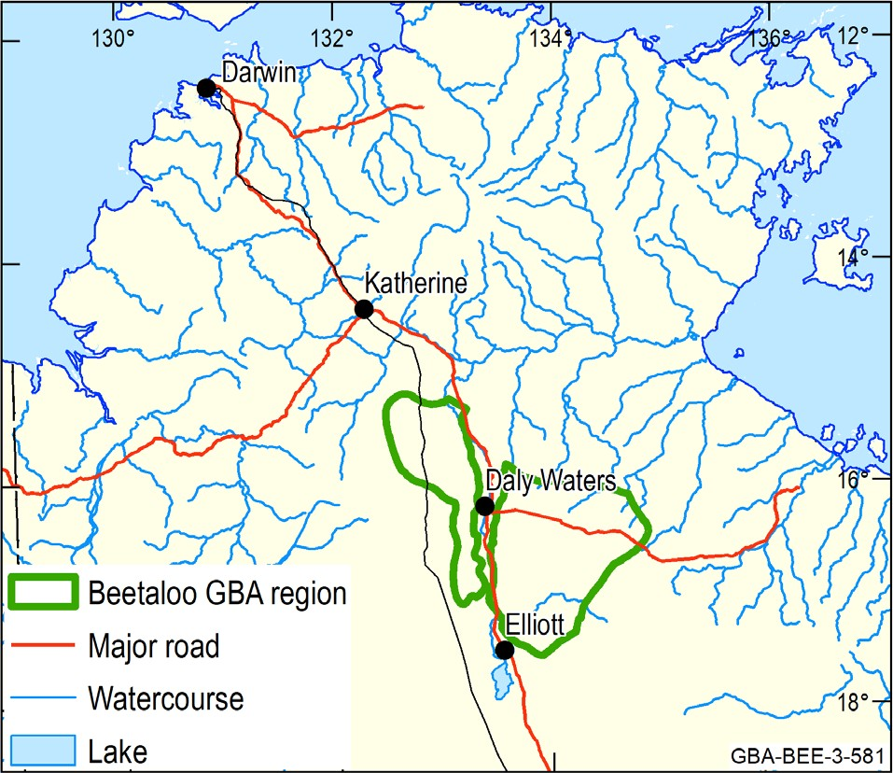

Surface water: Where activities are conducted in the vicinity of waterways, a small number of pathways have potential for impact. There is high confidence that existing mitigation strategies will prevent these impacts.
Element: GBA-BEE-3-581

Groundwater: Groundwater is the most probable source of water for unconventional gas resource development. The assessment has found that aquifers in the region, such as the Cambrian Limestone Aquifer, can supply this water without adverse regional impacts.

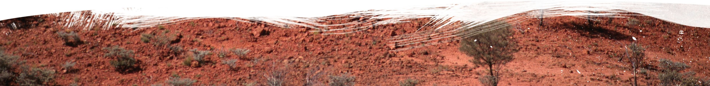
BIO764.0721
Environment: Invasive plants and broadscale landscape changes due to vegetation removal and vehicle movement have the strongest influence on threatened species and protected areas in the Beetaloo GBA region. There is high confidence that existing management controls can avoid and mitigate these potential impacts.
Protected fauna: The assessment prioritised 6 protected animals based on the importance of the Beetaloo GBA region to each species.
Potential impacts involve activities at the surface leading to increased invasive plants and animals, and vegetation removal. There is high confidence that existing management controls can avoid and mitigate these impacts.

Find out more
Huddlestone-Holmes CR et al. (2021) Impact assessment for the Beetaloo GBA region. Geological and Bioregional Assessment Program: Stage 3 synthesis. Department of Agriculture, Water and the Environment, Bureau of Meteorology, CSIRO and Geoscience Australia, Australia.
More information is available at bioregionalassessments.gov.au/gba

